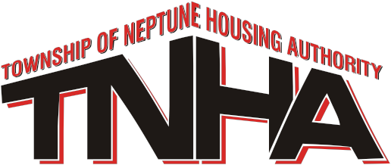

COMMISSIONERS
BEVERLY J. HOLLAND Chairman,
CAROL A. FOSTER Vice Chairman
DERRICK T. GRIGGS
EILEEN M. HOLLY
WINIFRED P. JOHNSON
KEITH G. VUONO, ESQ.
REV. JOHNNY R. WRIGHT

EXECUTIVE DIRECTOR AND SECRETARY-TREASURER
BART J. COOK, ESQ., PHM

1810 ALBERTA AVENUE
NEPTUNE, NEW JERSEY 07753
TELEPHONE 732-774-7692
FAX 732-774-9456

TOWNSHIP OF NEPTUNE HOUSING AUTHORITY
NOTICE OF REGULAR MEETING FOR

APRIL 20, 2021

FORMAT AND LOCATION CHANGE

Due to the recent COVID-19 restrictions on social distancing, notice is hereby given that the location/format has been changed for the regular scheduled meetings of the Neptune Township Housing Authority. All meetings are to be held at 530pm.
The meeting has been changed to a Zoom format. In preparation, please download the ZOOM Meeting application to your phone and or your computer.
Meeting ID: 587 270 1026 Password: 5UXV6j
You may also dial in by your location
Dial: 1-646-876-9923 US (New York)
Meeting ID: 587 270 1026
Password: 226550

Bart J. Cook, Esq. PHM
Executive Director

